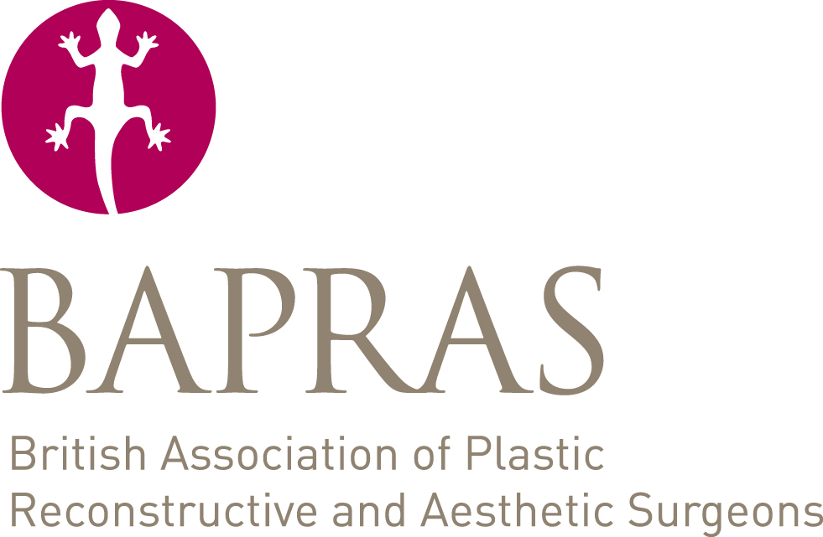BAPRAS Summer Scientific Meeting
26-28 June 2019, Bournemouth

Abstract Submission – Nurses Day

Presenting Author/contact information
Title
Forename
Surname
Phone
Email
Present Post/job title
Hospital/institution
Town

Alternate contact- name
Alternate contact- email

Additional authors (Title, forename, surname, institution, town)
Senior author? (select 1)
1
2
3
4
5
6

Free paper |  | Poster |  | (please select one)
Paper Title

Abstract text (no more than 200 words)

Please return form to gemma.adlington@bapras.org.uk. The closing date for receipt of abstracts is 15th March. Abstract submitters will be notified whether they’ve been accepted into the programme by 29 March.
Notes
The Programme Committee reserves the right to transfer any abstract to an alternative session if it considers this to be more appropriate.
Copyright is assumed by BAPRAS for publication of the abstracts on their website. Whilst this does not preclude publication of the results in the form of a paper elsewhere, it is hoped that the authors will submit their work to the JPRAS for future publication when appropriate.
Acknowledgement
An electronic acknowledgement will be sent by email on submission of your abstract. If you have any queries, please telephone the Secretariat on +44 (0)20 7831 5161 or email secretariat@bapras.org.uk. Your acknowledgement it not automated and may take up to 2 working days to be sent.
Papers submitted incorrectly will NOT be considered. Papers withdrawn from a meeting or not selected will not be automatically considered for the next Scientific Meeting, but may be resubmitted.
All correspondence regarding an abstract will be with the designated presenting author of the paper/poster indicated on the form. It is a requirement that all listed authors have agreed the final content of any submitted abstract.
Selection
All abstracts are anonymised before being considered by the Association. The “presenting author” will receive acceptance/rejection notification, and further information as applicable.
The panel’s decision on paper acceptance is final and no discussion will be entered into with authors

