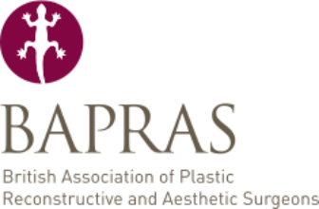

European Scholarships

Application Form

Please note, only typed applications will be accepted

Email completed application forms and attachments to bursaries@bapras.org.uk by 10 DECEMBER.

The European scholarships will be awarded at the February meeting of the Education Committee. Successful candidates are notified shortly after the meeting.

A total amount of £6,000 is available annually. The maximum value of one award is £1,000. The funds will be allocated at the discretion of the Education Committee.

Specialist Registrars (years 4-6) enrolled on a recognised training programme with the Specialist Advisory Committee in Plastic Surgery are eligible to apply.

Scholarships are available to enable Specialist Registrars from this country to visit any plastic surgical centre in Europe. Preference will be given to trainees travelling abroad without other financial awards and to persons applying for funding prior to travel. Candidates seeking funds to travel abroad in paid jobs will be considered less favourably.

Please include the following documents:
- PROPOSED ITINERARY
This should be detailed and should give costs and the reasons why you consider that these particular visits would be of value
- CURRICULUM VITAE (Maximum length of two pages)

NB: Applications that are incomplete or missing supporting documents will not be considered.

Full Name
Address
Telephone Number
Email
Present Post & Date of Appointment
Have you previously received any grant or fellowship from the Association? |  |  |  | Yes / No
Will the post you undertake be salaried? |  |  |  | Yes / No
Are you receiving any additional funding for your trip? |  |  |  | Yes / No
If YES, please state from whom

