Pump Priming Fund for Consumables

Application Form

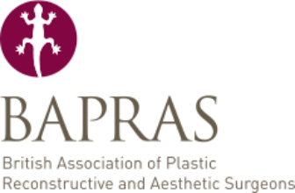
The BAPRAS Research Committee administers the BAPRAS Pump Priming Fund. It aims to make a single award of up to £20K each year.

Eligibility criteria for applicant
- Holder of National Training Number in plastic surgery or
- Consultant within 5 years of appointment.

Eligibility criteria for funding
- Consumable costs
- Equipment costs
- Salary or on costs will NOT be funded

Please return this form to secretariat@bapras.org.uk
The deadline for applications is 31 October

Lead applicant
Forename
Surname
Present appointment
Institution
Address
Postcode
Email address
Telephone number
Member of BAPRAS | YES / NO (delete as applicable)

Co-applicant
Forename
Surname
Present appointment
Institution
Member of BAPRAS | YES / NO (delete as applicable)

Title of research project

Scientific abstract (maximum 250 words)

Lay abstract (maximum 150 words)

Most recent /relevant publications (maximum 5)

Research background and methodology (maximum 1000 words)

Source of salary
Other funding secured
Research time frame

To be completed by lead applicant only

Funding requested (please be as detailed as possible)
Item | Detailed information | Cost

